Patrick Kilroy, [pkilroy@csu.fullerton.edu](mailto:pkilroy@csu.fullerton.edu)

Ashkii Kadenehii [ashkii97@csu.fullerton.edu](mailto:ashkii97@csu.fullerton.edu)

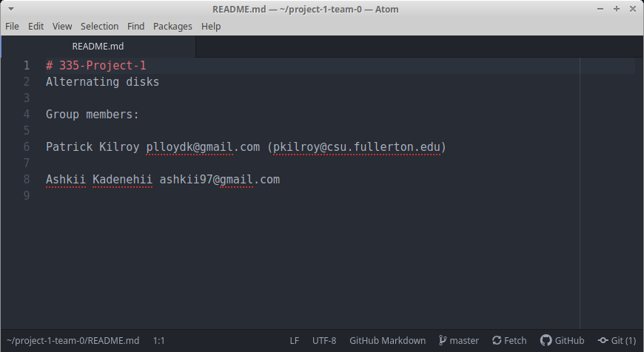

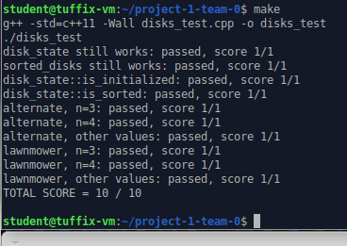

Function alternate sort (disks state)

Int count = 0

for i = 0 to n/2 do

For j = i to n traversing by 2 do

If current disk is light and next is dark

Swap disks

Increment count

Endif

Endfor

Endfor

Return disks state and count

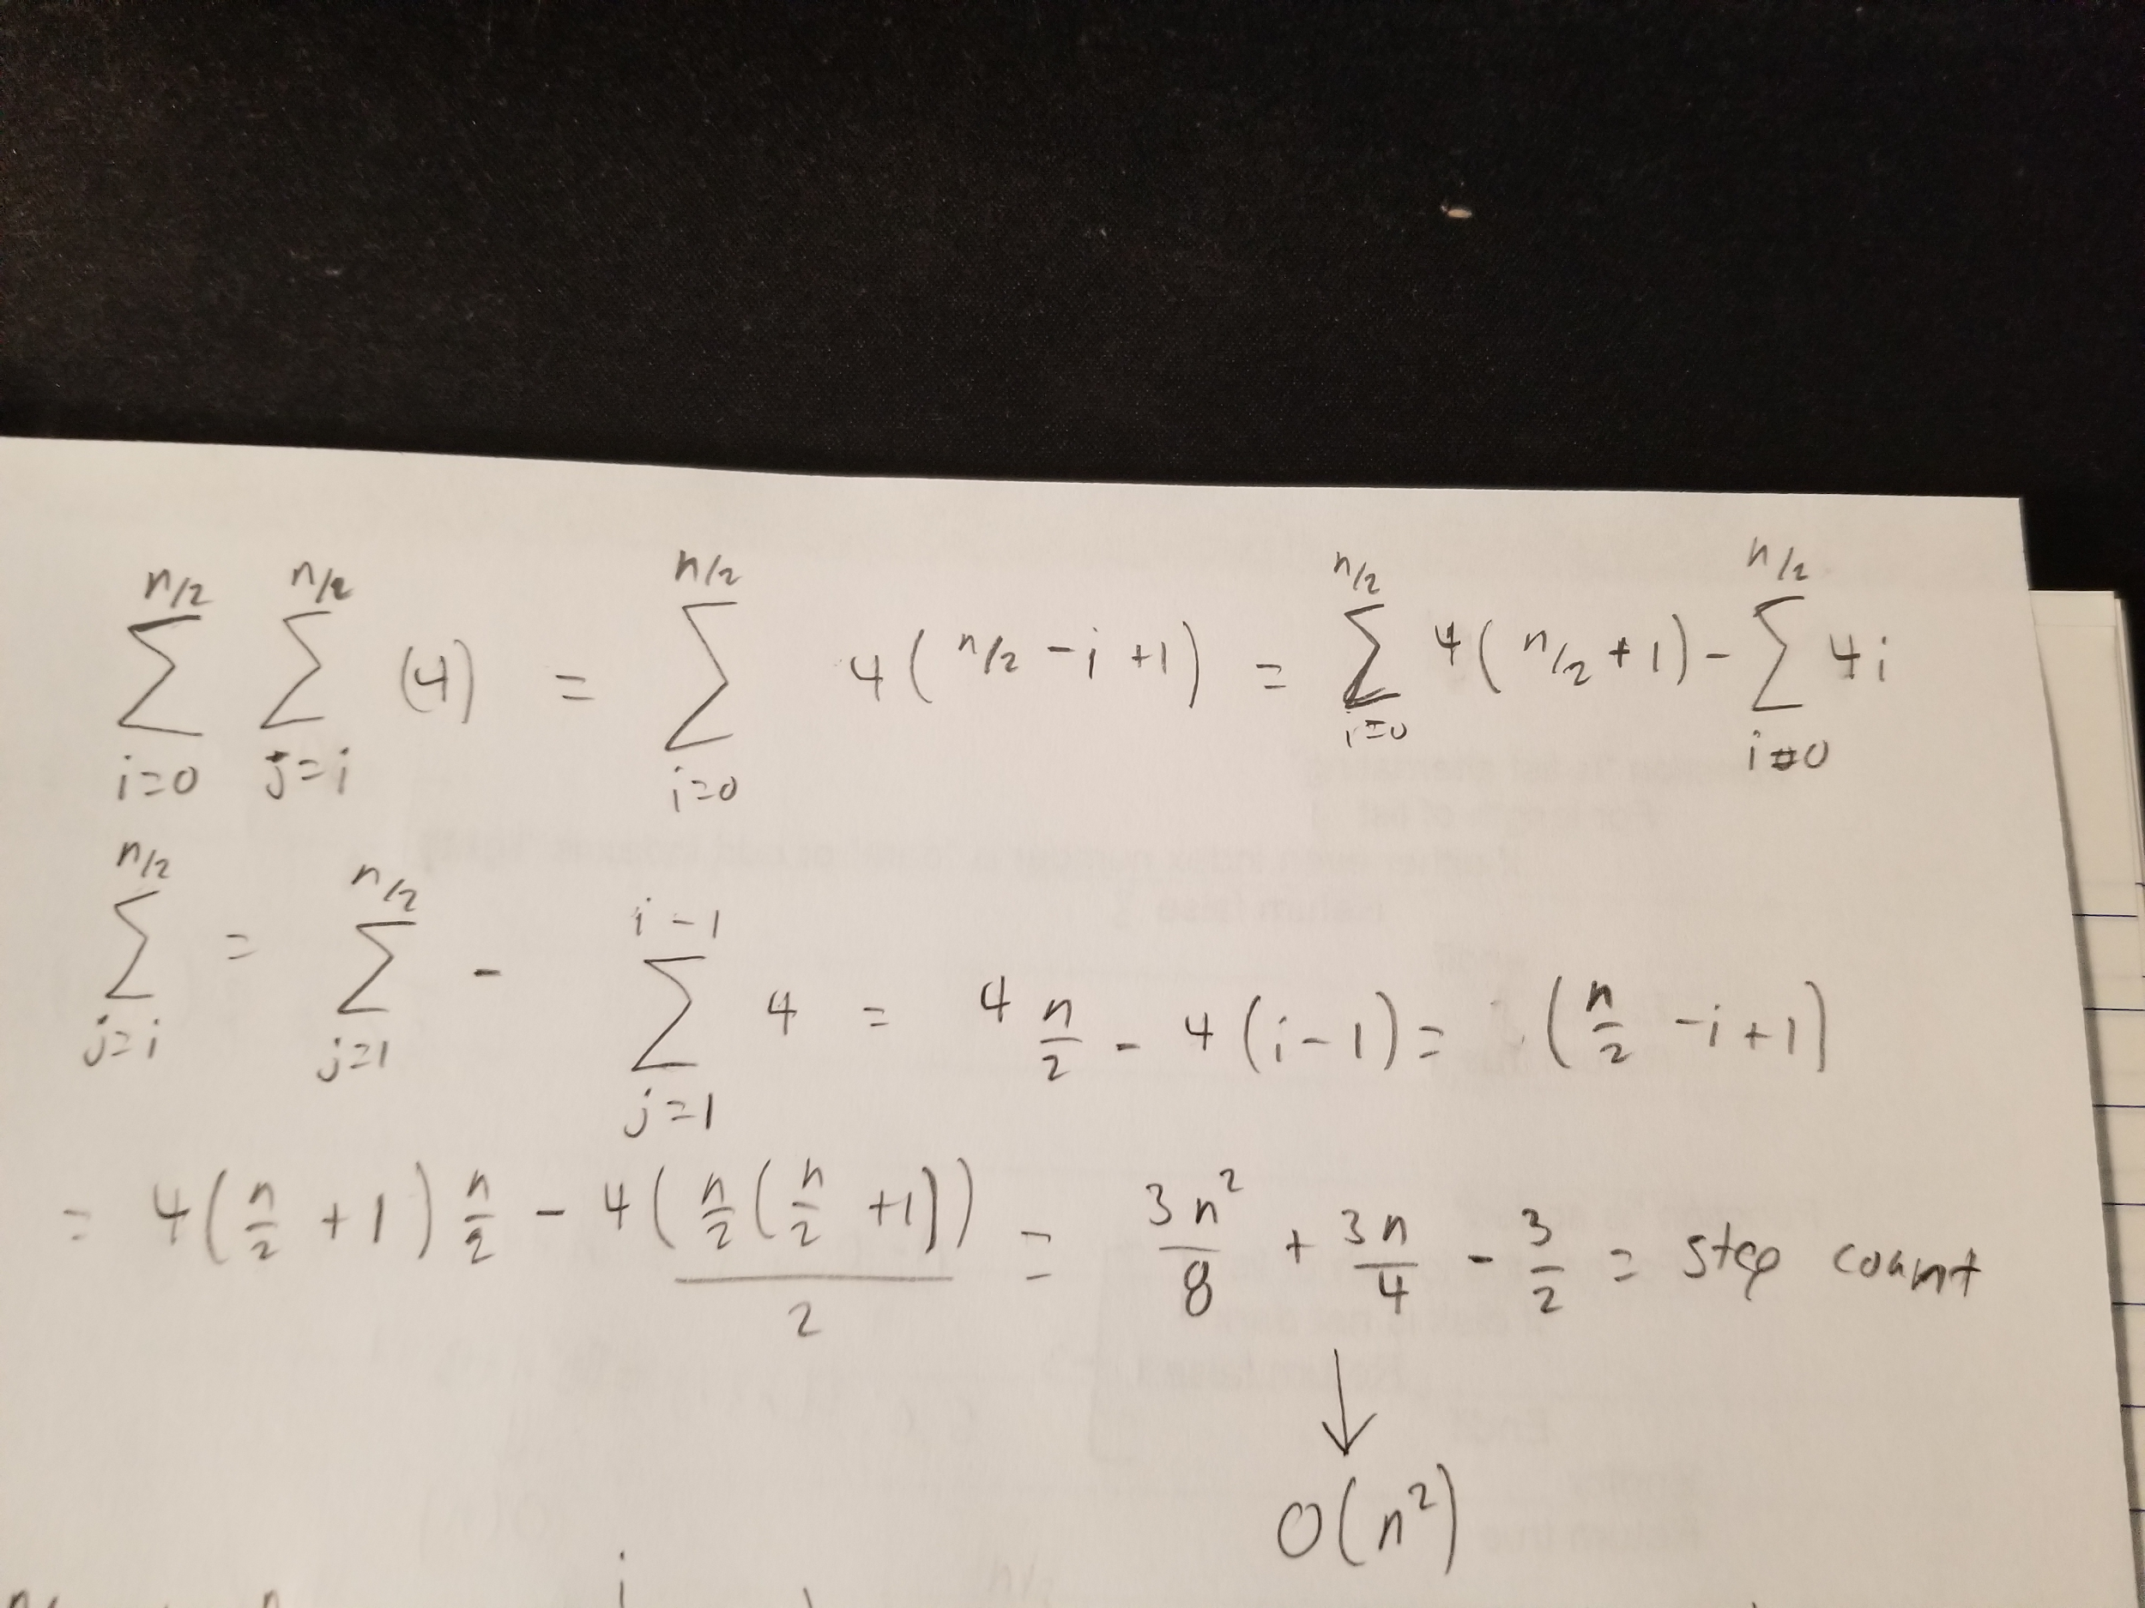

Function Lawnmower sort(disk state)

Int count = 0

Disk state after = before

Size = size of the list

For i = 0 to n/2 do

For j = i to size do

If current disk is light and next disk is dark

Swap disks

Count++

Endif

Endfor

For k = size - 2 to k>i do

If current disk is dark and next disk is light

Swap disks

count++

endif

Endfor

size--

Endfor

Return disks state and count

